In this lesson we are goin to loking on the filter nodes

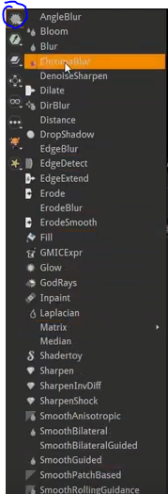
In The above marked is the filter node group and when you click on it then the filter nodes are shown
They are increadibly powerfull you can apply it to image or video or any object in your project and you can acheive a lot of result through them

So first we read a regular jpeg image

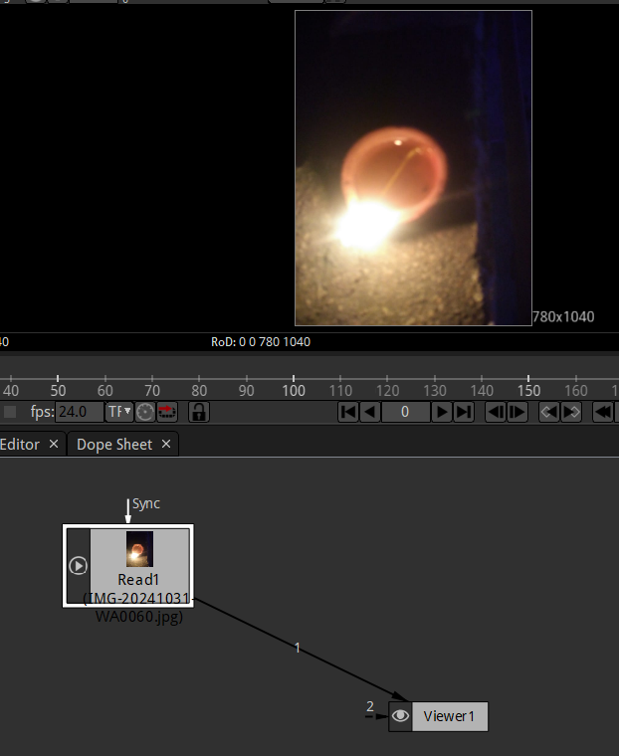
and now we make the frame in viewer window one frame by setting the starting and ending frame as one basically it is a single image
So basically we are goin to use natron like an image editor like Photoshop or GIMP
So lets apply filters here now
Now lets applyt a blur here

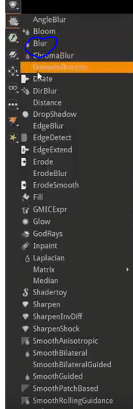
we place it between the source and the viewer node like below

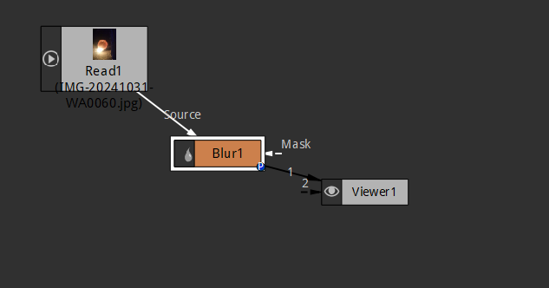
Now if we increase teh size propery in the Blur1 property in the property window as marked below

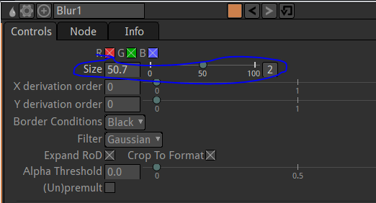
Now our image in teh viewer window is blurred as shown below

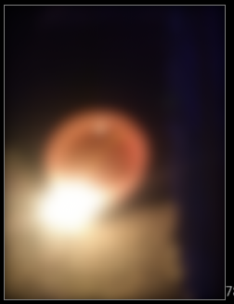
Now we output it with the help of writer node

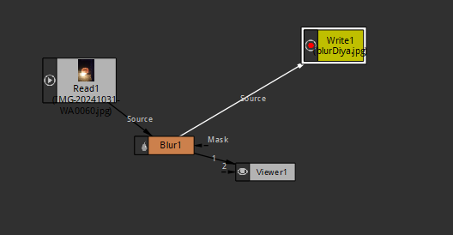
Now our node graph will look like above whatever goes in read node now goes in write node
So whatver is showing in viewer window should be shown in the output
Now click on render button in the riter node now teh blurred image will be outputted
So we have domne something that we could do in GIMP or Photohop in natron
Now delete the blur1 node
After deleting it, the links from blur1 to write and read node will be removed and now the links will be from read node to write and viewer node as shown below

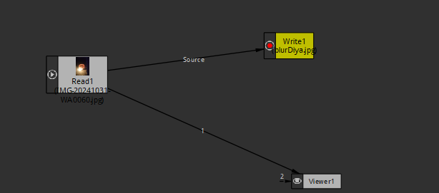
Now we apply another filter node that is glow as marked below

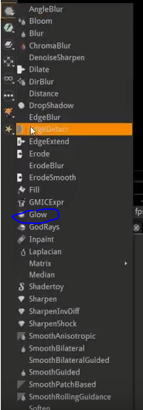
Now the node graph will be like below

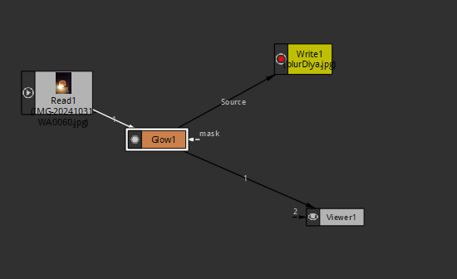
I think it make the color glow maybe increasing their color intensity that it will effect the surrounding pixel and look like everyting is glowing up
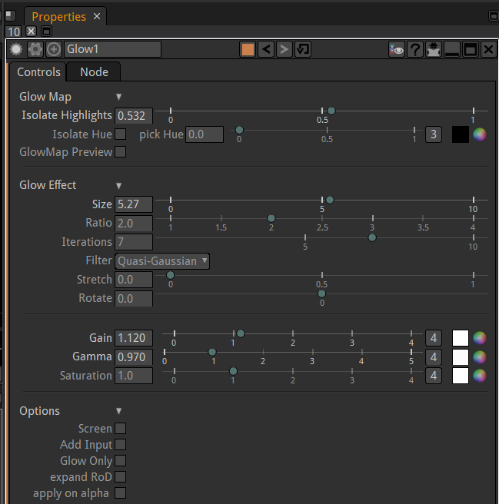
It sproperty is like above
I think if you decrease the Isolate Highlight then glow inreases and vice versa

Note:-

In color correct node properties as shown below
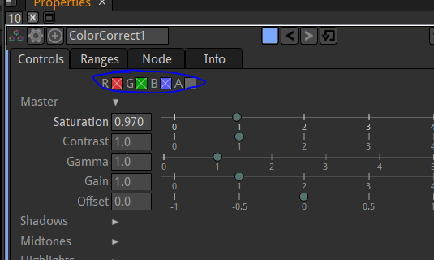
The marked above area is thh color spectrum that you want to effec while tuning Saturation or any proprty(I think so)
The color which has cross over it it means that color range range will be effected in rgb spectrum in teh image
Techer has removed teh redness in his face by just putting the cross on teh red by clicking on it and decrease the saturation to decrease only reddish part in teh image(who know)
In my output i did this
before
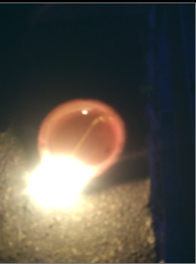

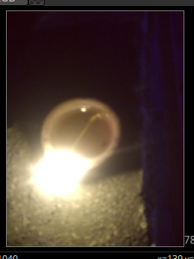
I just removed redness by putting cross on red only and reduce the saturation
3:10

It might be boring that we want to do compositive like things and not some photo editing Alright now we do some important
We remove the glow and coloor correct node in node graph and now make our video frame upto 100 in Project setting
So now we do have a video Now again add the filter node
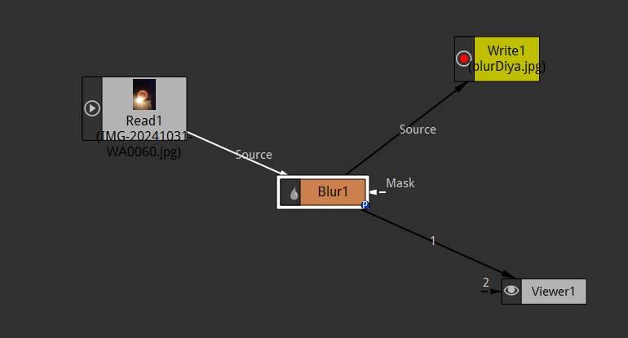
Now we make the picture 100 percent blurry
and now we set the keyframe if we don't set the keyframe then every frame will have a blur so we set the keyframe as shown below

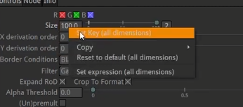
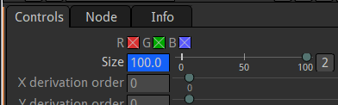
Now we set the keyframe such that frame1 has 100 percent blur and frame 15 has 0 percent blur
by taking the video pointer to 15 frame and then set the size parameter in blur properties as 0

Now what happens that initially video is blur and after 15 frames the image come into focus

So now we have like starts of a window going on here
So its now like sort of slideshow in the image
Maybe by frae 40 we might want to do different effect
We now add another node now that is God rays after the blur node in node graph

So what godrays gonna do from what we can tell
It looks wher the orgiginal image is and then you apply either a rotation or a scale or any other trandformation and it kind of blurs it from begin to final interanl picture orientation of the image

Below the properties of godrays

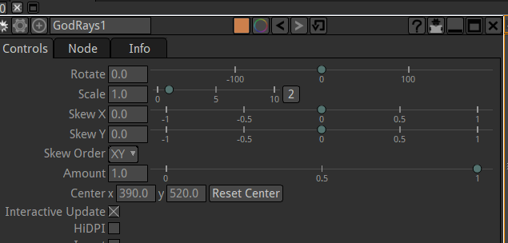
Now if we increase the rotate and rotate the internal picture components then it will look like below
Before

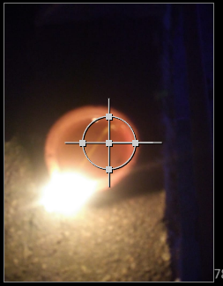
After
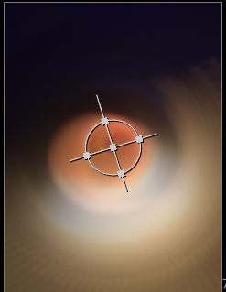
So now we got a little bit of blurriness out there which is cool So maybe we want to just create this kind of effects
but teacher thinks like that our scale will be better

Before

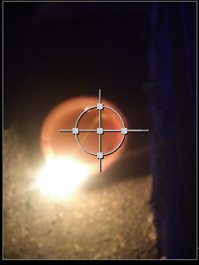
After increasing the scale

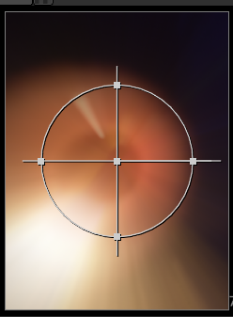
Now we animate the scale in godrays from frame 40 so we set the keyframe and set the scale as 1
and then in frame 50 we set it to 3 and then back in frame 60 we set it to normal that is 1.
when we run our video in Viewer window then intially it plays very slow because of extra process (maybe rendering in viewer window) but later if you play again then it play smoothly

6:45
So that's the effect we created
So what we are doing id blur and it is happening in the starting of teh video and godrays is happening in teh middle of the video
So teacher said that this way you can apply node in a certain portion of the video suh that blur ius added only in the initial part of the video

Play with different filters and see what they do
Dor example we see bloom

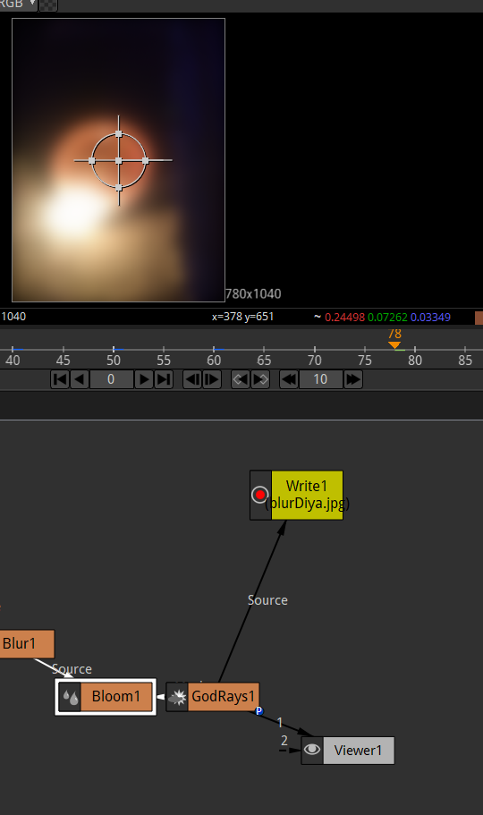
I think by bloom also there will be blurrinesss but i think it will start from a center point and then deisperse around and its outline can make a shape of a rectangle triangle etc

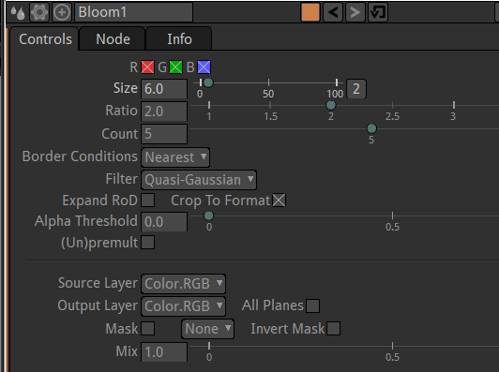

Now with the help of timeiline in natron you can animate filter

It was an image just suppose there was an animated background or just a single object on top of another
So play with them and understand that what they do that's what teacher has done to get familair with them

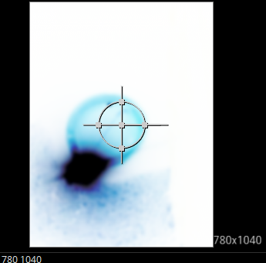
With the help of invert in color nodes we can ,make the video or image as above
Play with them and get familair with what they do and how they effect and bring different changes in your project
We will be using otther filter nodes to do some more advanced thing in future
See you in the next lesson

